The CRISP-DM Process Model

Project: <Name>

Project Group <ID>

Students:

Data Understanding

2.1 Collect Initial Data

Task Collect Initial Data
Acquire within the project the data (or access to the data) listed in the project resources. This initial collection includes data loading if necessary for data understanding. For example, if you intend to use a specific tool for data understanding, it is logical to load your data into this tool

Output Initial Data Collection Report
List all the various data that will be used within the project, together with any selection requirements for more detailed data. The Data Collection Report should also define whether some attributes are relatively more important than others.
Remember that any assessment of Data Quality should be made not just of the individual data sources but also of any data that comes from merging data sources. Merged data may present problems that do not exist in the individual data sources because of inconsistencies between the sources

Source and acquisition
Source: Amazon Reviews 2023. The corpus is licensed for academic use; no live or operational platform data is involved, and user/item identifiers in the public release are dataset-generated tokens rather than platform PII.
Acquisition: Files were pulled via the official huggingface_hub Python client. Total size is ~22.6 GB across 10 files (5 ratings tables + 5 metadata tables). The footprint sits well inside the project's compute constraint (200 GB working budget on the home workstation).
Data requirements planning
Interactions: for each vertical, who interacted with what, and when — the implicit-positive signal the recommender is trained on. The unfiltered (0-core) variant of the ratings table was chosen on purpose. A k-core filter repeatedly removes users and items with fewer than k interactions until every remaining user and item has at least k, so 0-core means no filtering at all, while 5-core keeps only users and items with at least five interactions each. Taking the 0-core table lets us run the 5-core filter ourselves on a pinned snapshot, whereas the release's pre-cored variants would lock in a filtering policy we want to be able to vary in ablations.
Item metadata: the cross-vertical bridge is item-side text and taxonomy — title, description, features, and the hierarchical category path — together with structured per-item attributes that vary by vertical (publisher and ISBN for books, directors for movies, runtime for music, manufacturer for games and toys). We pull the full per-vertical metadata table to cover all of these in one place.
Shared users: the cross-domain mapping function is supervised on users who appear in both source and target verticals. This is not a separate file — the corpus uses the same user identifier across verticals by construction, so the overlap is recovered by intersecting the user columns of two ratings tables. The actual overlap size after 5-core filtering is the gating check for §S2 and the central question of §2.3.
Temporal coverage: every interaction carries a timestamp (integer milliseconds since epoch), so the full multi-year review history of each vertical is retained at collection time rather than truncated to a fixed recent window. CRISP-DM prompts the team to decide how much history to use even when more is available; that decision is deferred to §2.3, where per-vertical timestamp coverage is profiled and a time-based train / validation / test split is defined. Retaining the entire history at this stage keeps that cut-off an evidence-based choice rather than prematurely discarding older interactions that may anchor long-lived user preferences feeding the cross-domain mapping.
Selection criteria
Selection was applied at three levels, narrowing from the whole corpus down to individual fields: which verticals to download, which file variants to take for each vertical, and which fields within a record we expect to actually consume. Each level is treated in turn below.
(a) Verticals. The 2023 corpus is partitioned into 33 top-level store categories. From these we kept only the entertainment-media cluster. Books, Movies_and_TV, CDs_and_Vinyl, Video_Games, and Toys_and_Games.
(b) File variants per vertical. For each vertical we keep two tables: the unfiltered (0-core) ratings table and the raw item metadata. Three other variants the release offers were rejected:
• Full review text (tens of GB per vertical). The bridge uses item-side text, not user-written reviews, so it would never reach the feature pipeline.
• Pre-built train/test splits. The evaluation harness defines its own splits; a ready-made one would lock in someone else's filtering policy and block ablations on the split.
• The global item-to-vertical map. Redundant with the per-vertical metadata we already hold.
(c) Fields per record. Within a record, the fields that matter are listed below, grouped by the role they play in the model:
• Identity and interaction signal: user_id, parent_asin, rating, timestamp. These four are the only columns in the ratings table. We are still contemplating how best to turn the 1–5 rating into a training signal, and currently expect this scheme to work best: ratings of ≥4 are treated as positives; 3-star ratings are dropped as neutral, too ambiguous to label either way; and 1–2-star ratings are kept as explicit negatives alongside negatives sampled from items the user never interacted with, optionally up-weighting the explicit negatives as an ablation. The same encoding is applied to both the single-vertical baseline and the cross-domain model so the comparison stays like-for-like.
• Cross-vertical bridge inputs: title, description, features (the item-side text, encoded by sentence-transformers/all-MiniLM-L6-v2 into a 384-dim vector), together with categories and main_category (the hierarchical taxonomy, used both as a categorical feature and for the planned categories-only ablation).
• Structured side features: details (a dictionary of per-item attributes that varies by vertical — Publisher / ISBN for Books, Directors for Movies, Run time for CDs, Rated for Games, Package Dimensions for Toys), store (brand / publisher / studio), and author (Books only).
• Popularity priors: average_rating, rating_number. They are candidate features for the per-vertical recommender, but not central to the cross-domain bridge.
• Unused: images and videos (URLs only, no binaries in scope), price (sparse and irrelevant to taste transfer), subtitle (largely cosmetic), and bought_together (verified empty — see below).

Insertion and extraction notes
Formats. Ratings tables are plain CSV. Metadata tables are JSON-Lines. The metadata JSONL files are in plain UTF-8 JSON, one record per line. Timestamps in the ratings table are integer milliseconds since epoch; rating values are integers in {1, 2, 3, 4, 5}.
Free-text encoding. title, description, and features are not pre-encoded in the release. They are passed through sentence-transformers/all-MiniLM-L6-v2 in the §S3 feature pipeline, producing a 384-dim vector per item. Multi-line description / features fields are joined with newlines before encoding.
Missing attributes. Several fields are empty for a non-trivial fraction of items in every vertical. The downstream feature pipeline falls back to title + store + details when the rich text is missing rather than dropping the item — preserving catalog coverage matters more than feature richness on long-tail items.
bought_together is universally null. Across all items in the five downloaded catalogs, the bought_together field is null for 100 % of records, so we drop it.
Join key. parent_asin (10-character Amazon ASIN at the parent-product level) is the join key between the ratings table and the metadata table within a vertical.
main_category caveat. The main_category field on a meta record is the live Amazon store category at scrape time, not the dataset's partition label. Movies_and_TV records can read "Prime Video"; CDs_and_Vinyl records can read "Digital Music". The source of truth is set to the meta file the record came from.
Merge-quality considerations
Ratings and Metadata join within a vertical. The two tables were produced from the same crawl, so the join is expected to be near-complete, but some interactions are likely to reference ASINs that no longer have a metadata record (delisted items, scrape gaps). Items without metadata cannot be embedded and must be filtered out.
Initial collection inventory
Size and names of dataset items:
• Books.csv — 1.69 GB (ratings)
• Movies_and_TV.csv — 1.00 GB (ratings)
• CDs_and_Vinyl.csv — 0.28 GB (ratings)
• Toys_and_Games.csv — 0.93 GB (ratings)
• Video_Games.csv — 0.26 GB (ratings)
• meta_Books.jsonl — 14.70 GB, 4,448,181 items
• meta_Movies_and_TV.jsonl — 1.29 GB, 748,224 items
• meta_CDs_and_Vinyl.jsonl — 0.95 GB, 701,959 items
• meta_Toys_and_Games.jsonl — 2.64 GB, 890,874 items
• meta_Video_Games.jsonl — 0.44 GB, 137,269 items
Total: 22.59 GB on disk, 6,926,507 items across the 5 catalogs.

2.2 Describe Data
Task Describe Data
Examine the "gross" properties of the acquired data and report on the results.

Output Data Description Report
Describe the data which has been acquired including: the format of the data, the quantity of the data (e.g. the number of records and fields within each table), the identities of the fields and any other surface features of the data which have been discovered.

Formats and attribute types. Interaction data is one csv table per vertical with four columns: a user identifier and an item identifier (Amazon ID tokens, stored as text), an integer rating on a 1–5 scale, and a timestamp in milliseconds. Item metadata is one JSON-Lines file per vertical — one record per line — sharing a common schema across verticals: text fields (title, store, main_category), list fields (description, features, categories, images), a details dictionary, and numeric fields (average_rating, rating_number, price). The ratings load straight into a dataframe; the metadata is streamed line by line.
Volume. The snapshot holds 71.7M interactions, about 6.9M items, and on the order of 29M user-rows before users are de-duplicated across verticals. Books is the largest vertical (29.1M interactions) and Video Games the smallest (4.6M). Interactions per user are low everywhere — 1.6 to 2.8 on average — the first sign that the raw data is dominated by very light users, which motivates 5-core filter exploration.
Items are rated far more repeatedly in the screen-and-play verticals (Video Games 33, Movies & TV 23 per item) than in the catalog-heavy ones (Books 6.6, CDs & Vinyl 6.8).
Vertical | Interactions | Users | Items | Per user (AVG) | Per item (AVG)
Books | 29,139,329 | 10,297,355 | 4,446,065 | 2.83 | 6.55
Movies & TV | 17,158,519 | 6,503,429 | 747,764 | 2.64 | 22.95
CDs & Vinyl | 4,772,071 | 1,754,118 | 701,673 | 2.72 | 6.80
Video Games | 4,555,500 | 2,766,656 | 137,249 | 1.65 | 33.19
Toys & Games | 16,052,440 | 8,116,226 | 890,667 | 1.98 | 18.02
Table 1. Volumetric summary per vertical (0-core).
Rating distribution. All five verticals skew heavily to the top of the scale: five-star interactions alone make up 61–74% of each table, and the positive (≥4) share ranges from 74.5% in Video Games to 87.3% in CDs & Vinyl. This skew is the empirical basis for treating a rating of ≥4 as a positive, and the reason explicit one- and two-star negatives are comparatively scarce.
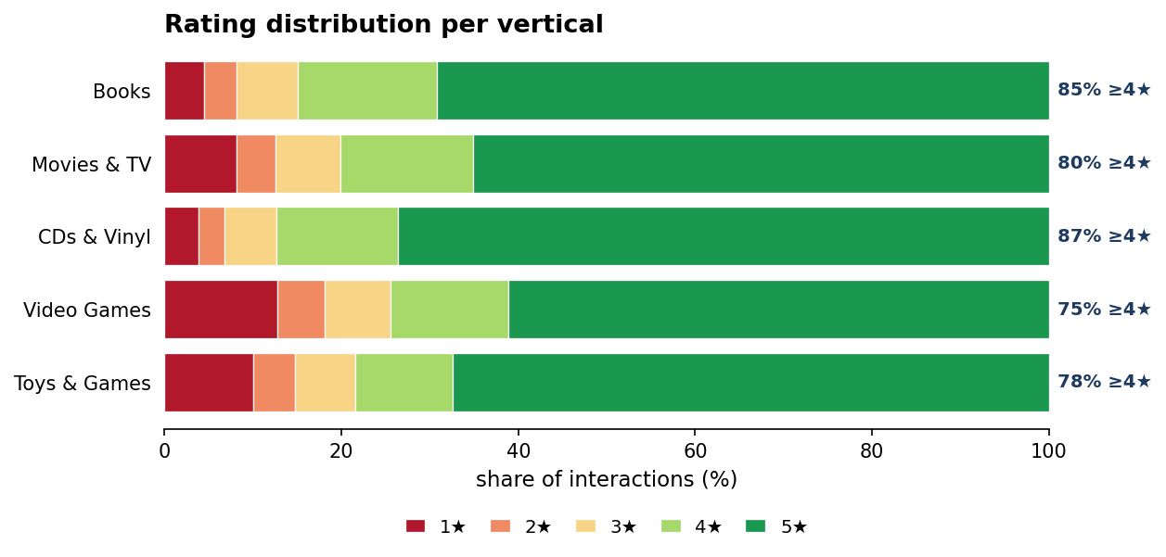
Figure 1. Rating distribution per vertical, as a share of interactions by star rating.
Timestamp coverage. Every vertical spans a long history: first interactions fall in 1996–1998 and the last in September 2023, a 25–27-year window, with volume heavily concentrated in the most recent decade. This concentration matters for the planned time-based split, in which interactions are partitioned chronologically — earlier ones for training, later ones held out for validation and test — so the model is evaluated on predicting future interactions from past ones rather than on a random sample. The dense recent decade leaves enough data on both sides of a recent cut-off for that split to be well-populated.
Sparsity. Both the items-per-user and users-per-item distributions are extremely heavy-tailed. The median user has rated a single item in every vertical, and even the 90th-percentile user has rated no more than five; the long tail is heaviest on the item side, where the 99th-percentile Video Games item is rated 537 times. This fat-head, long-tail shape means cold-start is the norm rather than the exception — precisely the condition the 5-core filter and the cross-domain signal are meant to address.
Metadata completeness. Field population varies sharply by vertical and is the main driver of the pair choice in §2.3. Identifiers and popularity fields (title outside Movies, main_category, average_rating, rating_number) are near-universal, but the rich-text fields the content bridge relies on are uneven: description is populated for only 41–66% of items, and features ranges from essentially absent (CDs & Vinyl 0.2%, Movies & TV 5%) to common (Books 88%, Toys & Games 80%). Movies & TV is the thinnest catalog overall — only 58% of its items even carry a title — which is the caveat attached to the Books→Movies pair in §2.3.
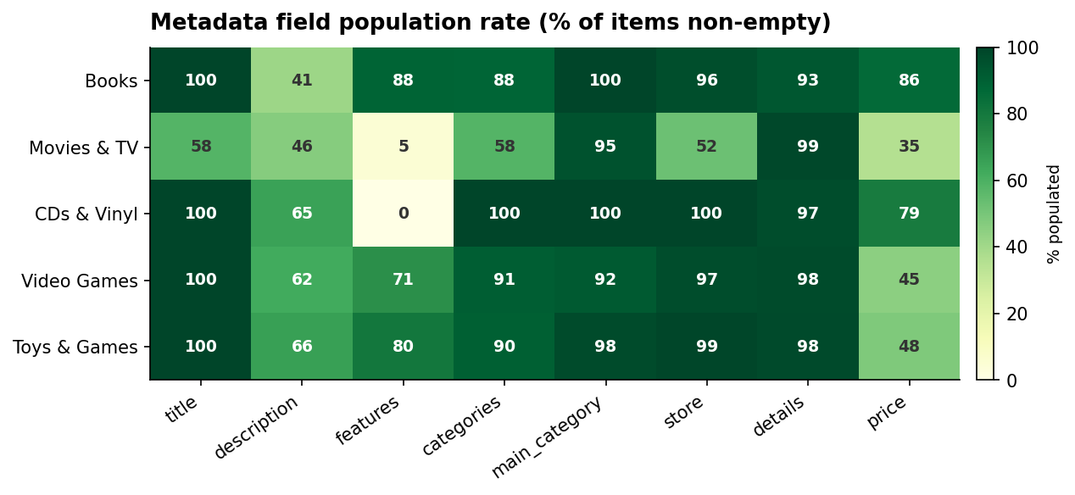
Figure 2. Metadata field population rate by vertical (% of items with a non-empty value).
Category structure. Category paths are present for most items (58–100% by vertical) and each vertical resolves to a single clean root ("Books", "CDs & Vinyl", "Video Games", and so on), confirming that the main_category field carries the live store label rather than the dataset partition. Path depth and breadth are richer in Books and Toys than in the effectively single-node music tree, giving the taxonomy half of the bridge more to work with there.
Join integrity. Within a vertical the ratings and metadata tables join on the item identifier. Intersecting the two key sets shows zero orphan interactions in every vertical — every rated item has a metadata record — so no interactions are dropped for missing metadata at ingest.

2.3 Explore Data
Task Explore Data
This task tackles the data mining questions, which can be addressed using querying, visualization and reporting. These analyses may address directly the data mining goals. However, they may also contribute to or refine the data description and quality reports, and feed into the transformation and other data preparation needed for further analysis.

Output Data Exploration Report
Describes results of this task including first findings or initial hypotheses and their impact on the remainder of the project. The report possibly also covers graphs and plots which indicate data characteristics or lead to interesting data subsets for further examination

The 5-core filter. After filtering, the verticals retain between 0.8M (Video Games) and 9.5M (Books) interactions and between 95k and 776k users. This filtered snapshot is what overlap is measured on.
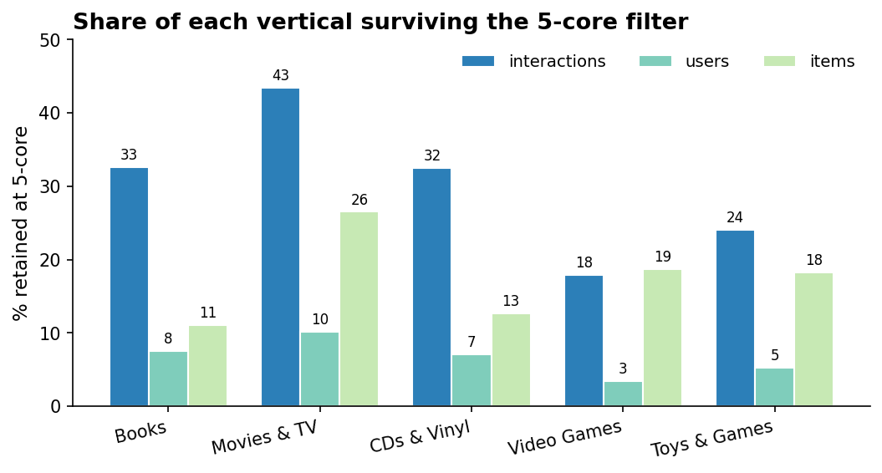
Figure 3. Share of each vertical (interactions, users, items) surviving the 5-core filter.
Pairwise user overlap. Because the corpus uses one user identifier across verticals, shared users are recovered by intersecting user columns. The shared users of a pair are exactly the training set for its source→target mapping — each one supplies a (source-embedding, target-embedding) pair the mapping learns from — so the project sets a planning-phase floor of roughly 10,000 shared users, below which the mapping has too few examples to fit reliably. After 5-core, eight of the ten vertical pairs clear that floor; only Toys & Games ↔ CDs & Vinyl (7.75k) and CDs & Vinyl ↔ Video Games (4.4k) fall short. Books anchors the strongest pairs — Books ↔ Movies & TV (127k) and Books ↔ Toys & Games (87k) lead by a wide margin — consistent with Books being the largest and most-connected vertical and the natural source.
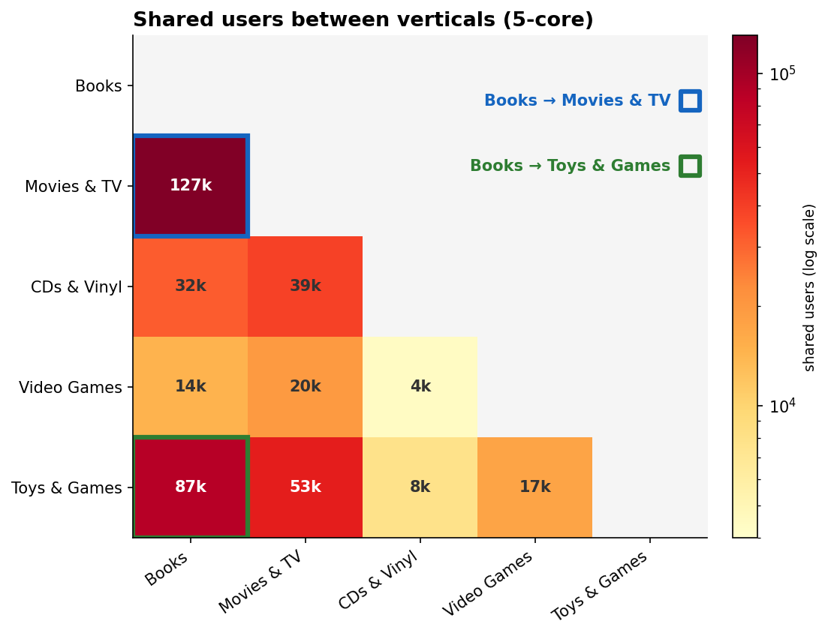
Figure 4. Pairwise shared users after the 5-core filter (log colour scale; candidate pairs outlined).
Choosing the source→target pair. The choice trades training signal (overlap) against content signal (catalog richness). The full ranking of the ten pairs is below.
Source → Target | Shared users (5-core) | Clears ~10k? | Avg richness
Books → Movies & TV | 127,188 | yes | 0.65
Books → Toys & Games | 87,225 | yes | 0.81
Movies & TV → Toys & Games | 52,794 | yes | 0.70
Movies & TV → CDs & Vinyl | 38,769 | yes | 0.71
Books → CDs & Vinyl | 32,027 | yes | 0.82
Movies & TV → Video Games | 19,615 | yes | 0.69
Toys & Games → Video Games | 17,202 | yes | 0.85
Books → Video Games | 14,478 | yes | 0.80
Toys & Games → CDs & Vinyl | 7,750 | no | 0.87
CDs & Vinyl → Video Games | 4,399 | no | 0.86
Table 2. Candidate source→target pairs ranked by 5-core shared-user overlap. Source is the larger vertical; richness averages title / description / categories population.
Two candidates dominate. Books → Movies & TV has the highest overlap of any pair (127k) and is the standard benchmark in the cross-domain literature, but Movies & TV is the poorest-described catalog in the snapshot (title 58%, features 5%, description 47%), so the content half of the bridge would lean heavily on the Books side. Books → Toys & Games has lower but still ample overlap (87k) and a far richer target catalog (title 100%, features 80%), giving both the text and category bridges more to work with. Both clear the floor comfortably, so this is a genuine trade-off rather than a clear winner.
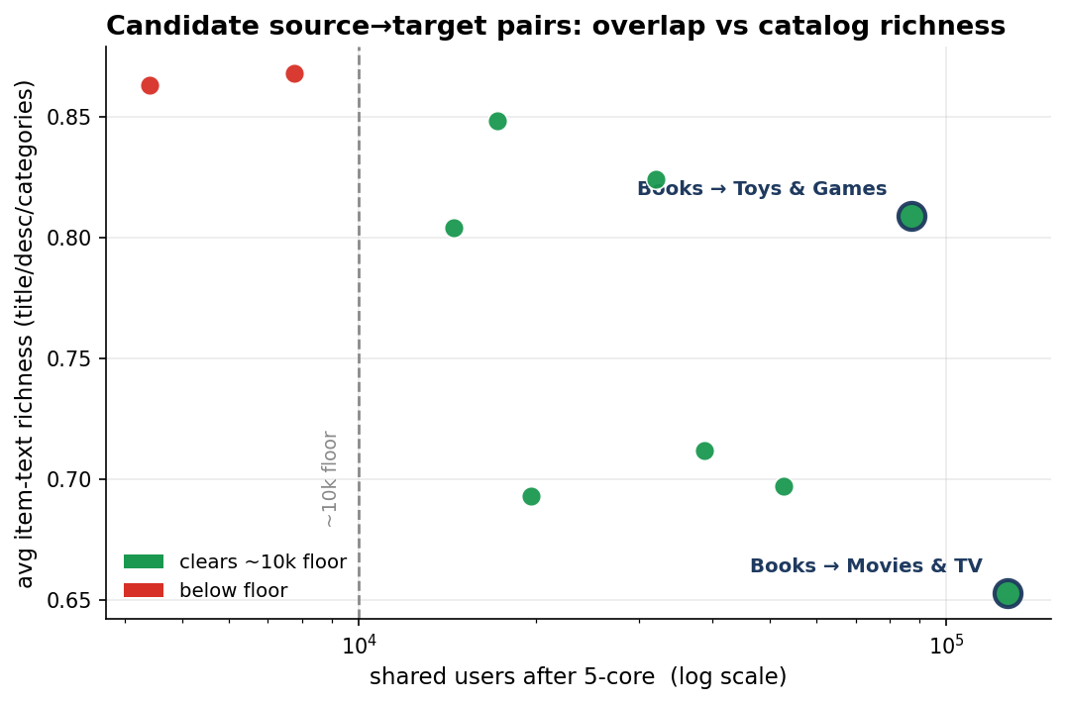
Figure 5. Candidate pairs: 5-core overlap (log scale) against average item-text richness.
Recommendation. We recommend Books → Movies & TV: the roughly 45% larger overlap and direct comparability with prior work outweigh the metadata gap, which is mitigable by leaning on Books-side text and falling back to titles for sparse movies. The pair is left open here for the team to confirm before §3.1 (Select Data) locks it.
First findings and impact. Four properties carry into the rest of the project: the heavy positive skew supports the binary-positive encoding discussed in §2.1; the pervasive cold-start (most users have one or two interactions) is exactly what cross-domain transfer is meant to relieve; the absence of orphan interactions means no item-side cleaning is needed for the within-vertical join; and the uneven metadata means the content bridge's strength is vertical-dependent and must be checked per pair in §2.4 and §3.

2.4 Verify Data Quality
Task Verify Data Quality
Examine the quality of the data, addressing questions such as: Is the data complete (does it cover all the cases required)? Is it correct or does it contain errors, and if there are errors how common are they? Are there missing values in the data? If so, how are they represented, where do they occur and how common are they?

Output Data Quality Report
List the results of the data quality verification; if there are quality problems, list possible solutions.

Completeness. The data covers the cases the project needs. Within each vertical the ratings and metadata tables join fully on the item identifier — zero orphan interactions, so no rated item lacks a metadata record. The interaction keys are complete as well: no row in any vertical is missing a user or item identifier. The one completeness gap is on the content side, addressed next.
Missing values. Missing data is confined to the descriptive metadata fields and is uneven across verticals (Figure 2). Identifiers, ratings, timestamps, and popularity fields are fully populated, but the rich text the content bridge consumes is patchy: description is present for 41–66% of items, features ranges from near-absent (CDs & Vinyl 0.2%, Movies & TV 5%) to common (Books 88%), and Movies & TV is missing a title on 42% of its catalog. Missing values are represented as empty lists or nulls, not coded sentinels. The feature pipeline first falls back to title, store, and details when the richer fields are empty. The residual items with no usable text at all are not dropped but kept with a placeholder content vector — a single shared "no-content" embedding that fills the slot the text encoder would otherwise produce — so the item still participates in the model through its collaborative signal (the users who interacted with it). Removal is avoided deliberately: deleting a text-poor item would also delete every interaction with it, which can cascade into dropping its users and re-introduce the sparsity the 5-core filter just removed, and it would bias the catalog against exactly the cold, long-tail items that cross-domain transfer is meant to help.
Correctness. Three correctness issues surfaced, all minor. First, the rating scale behaves: all five values 1–5 occur, and the only out-of-range entries are four rows in Books that carry a 0 (0.00001% of that table), which are dropped. Second, the main_category field holds the live store label at scrape time, not the dataset partition — a Movies & TV record can read "Comedy" or "Drama" rather than the vertical name — so the source of truth for an item’s vertical is the file it came from, never main_category; the field also mixes synonymous labels for the same vertical, and the free-text categorical fields (categories, store) carry the usual casing and near-duplicate variants, all normalised in §3. Third, bought_together is null for 100% of the 6.9M items in the snapshot; it carries no signal and is dropped.
Duplicates and timestamps. There are zero duplicate (user, item) interactions in any vertical. All timestamps are positive and fall between 1996 and September 2023, so the time axis is safe to use directly for the time-based split.
File structure. The ratings tables are flat comma-separated files; every one of the 71.7M rows across the five verticals parses into exactly four fields, so the delimiter is applied consistently and no record is truncated or misaligned. The metadata is JSON-Lines with one valid record per line.
Risks. Two items cannot be closed here and carry forward. The cross-vertical user join relies on the corpus guarantee that a user identifier denotes the same person in every vertical; this is taken as given, and the consequential quantity — how many such users survive filtering — is the overlap measured in §2.3. And because metadata richness is vertical-dependent, the strength of the content bridge will vary by pair; the thin Movies & TV catalog in particular must be validated against the chosen pair in §3 before it is relied on.

Check | Result over the full snapshot | Action
Orphan interactions (join) | 0 in all verticals | none; keep as a pipeline guard
Null user / item keys | 0 in all verticals | none
Duplicate interactions | 0 in all verticals | none; no de-duplication
Rating values | 1–5, except 4 zero rows in Books | drop the 4 rows
Timestamps | positive, 1996 – Sep 2023 | none; safe for the time split
Flat-file structure | every row parses into exactly 4 fields (71.7M rows) | none
Rich-text fields | uneven (Fig. 2): description 41–66%, features 0.2–88% | title / store / details fallback
main_category | live store label, not the partition | use the file-of-origin label
bought_together | 100% null (6.9M items) | drop at ingest
Cross-vertical user identity | corpus guarantee; overlap quantified in §2.3 | accept; overlap is the gate
Table 3. Data quality summary: checks, results over the full snapshot, and the action for each.

Data Preparation

3.1 Select Data

Task Select data
Decide on the data to be used for analysis. Criteria include relevance to the data mining goals, quality, and technical constraints such as limits on data volume or data types.

Output Rationale for Inclusion / Exclusion
List the data to be used/excluded and the reasons for these decisions

<Place your text here>

3.2 Clean Data
Task Clean Data
Raise the data quality to the level required by the selected analysis techniques. This may involve selection of clean subsets of the data, the insertion of suitable defaults or more ambitious techniques such as the estimation of missing data by modeling

Output Data Cleaning Report
This report describes the decisions and actions that were taken to address the data quality problems reported during the Verify Data Quality Tas

<Place your text here>

3.3 Construct Data
Task Construct Data
This task includes constructive data preparation operations such as the production of derived attributes, complete new records, or transformed values for existing attributes.

Output Derived Attributes
Derived Attributes are new attributes that are constructed from one or more existing attributes in the same record. An example might be area =length * width.
Why should we need to construct derived attributes during the course of a data mining investigation? It should not be thought that only data from databases or other sources is the only type of data that should be used in constructing a model. Derived attributes might be constructed because:
Background knowledge convinces us that some fact is important and ought to be represented although we have no attribute currently to represent it.
The modelling algorithm in use handles only certain types of data, e.g. we are using linear regression and we suspect that there are certain nonlinearities that will be not be included in the model.
The outcome of the modelling phase may suggest that certain facts are not being covered.

<Place your text here>

Output Generated Records
Generated Records are completely new records which add new knowledge or represent new data which is not otherwise represented, e.g., having segmented the data, it may be useful to generate a record to represent the prototypical member of each segment for further processing.

<Place your text here>

3.4 Integrate Data
Task Integrate Data
These are methods whereby information is combined from multiple tables or other information sources to create new records or values

Output Merged Data
Merging tables refers to joining together two or more tables that have different information about the same objects. At this stage it may also be advisable to generate new records. It may also be recommended to generate aggregate values.

Aggregation refers to operations where new values are computed by summarizing together information from multiple records and/or tables

<Place your text here>

3.5 Format Data
Task Format Data
Formatting transformations refer to primarily syntactic modifications made to the data that do not change its meaning, but might be required by the modeling too.

Output Reformatted Data
Some tools have requirements on the order of the attributes, such as the first field being a unique identifier for each record or the last field being the outcome field the model is to predict.

<Place your text here>

